웹 프로그래밍 3주차 과제 4

201905153 오세훈

메인화면 수정 전

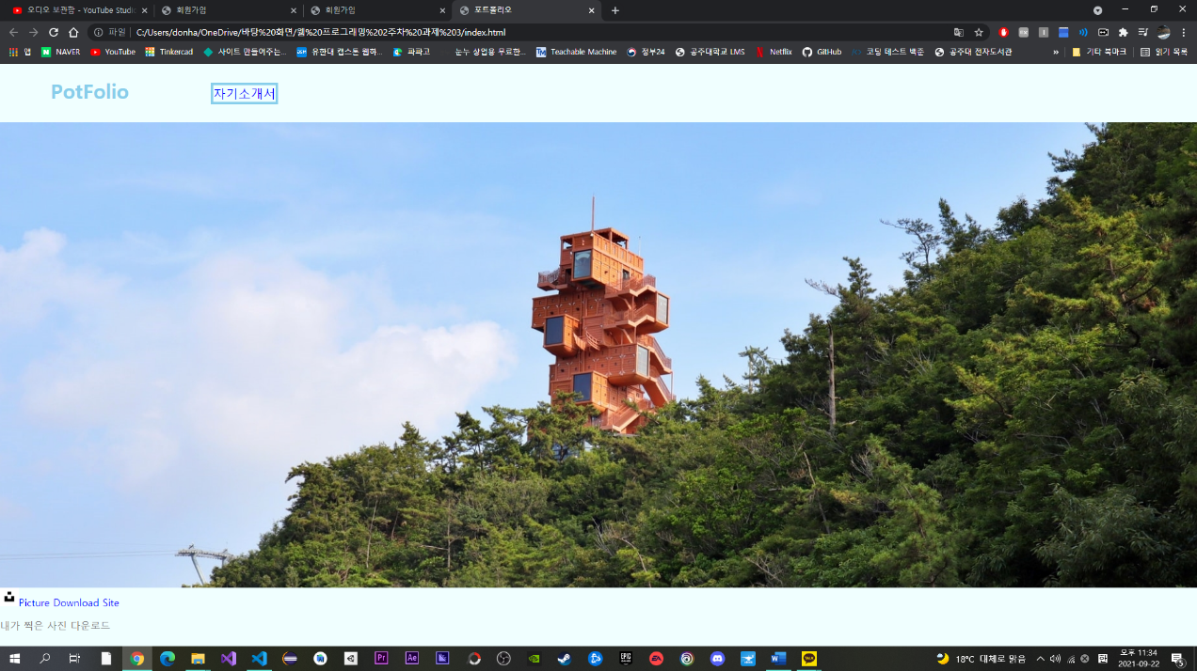

메인화면 수정 후

메인 화면의 레이아웃을 수정하였고 프로필, 취미, 회원가입을 추가로 만들었습니다. 폰트도 변경하고 음악 재생 위젯을 추가했습니다.

자기소개서 변경 전

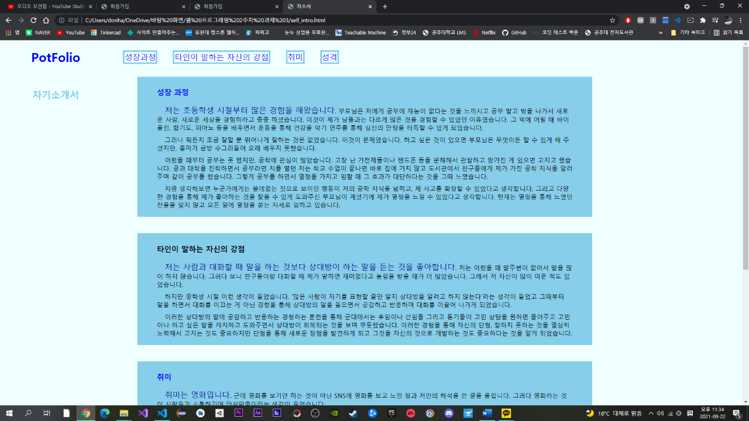

자기소개서 변경 후

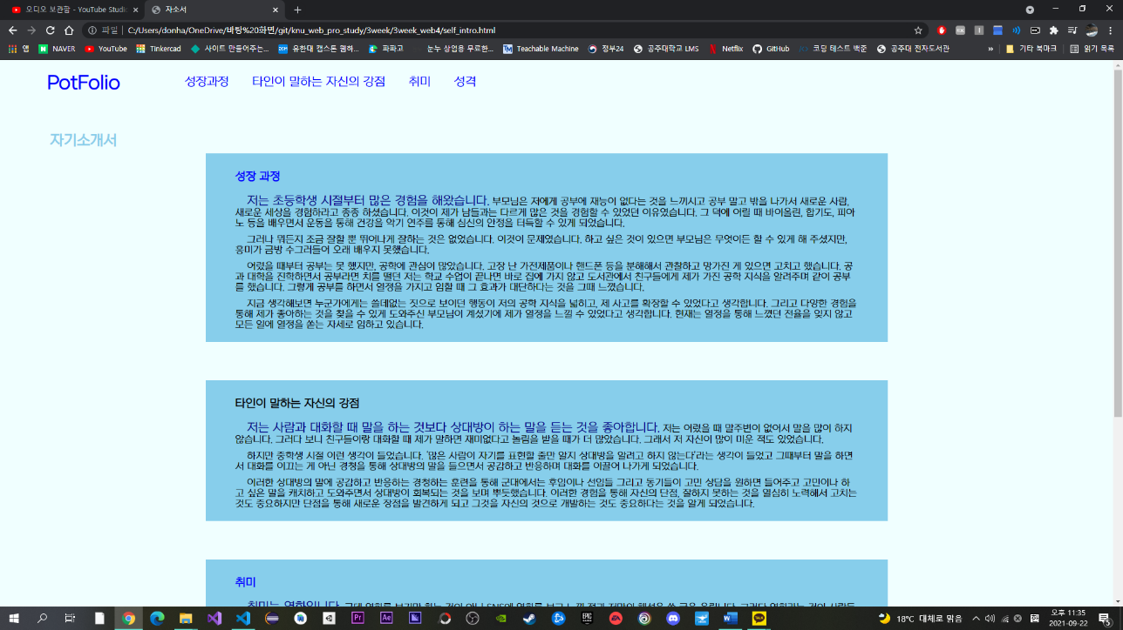

폰트를 수정하였고 nav 안에있던 리스트의 모양을 바꿨습니다.

프로필 화면

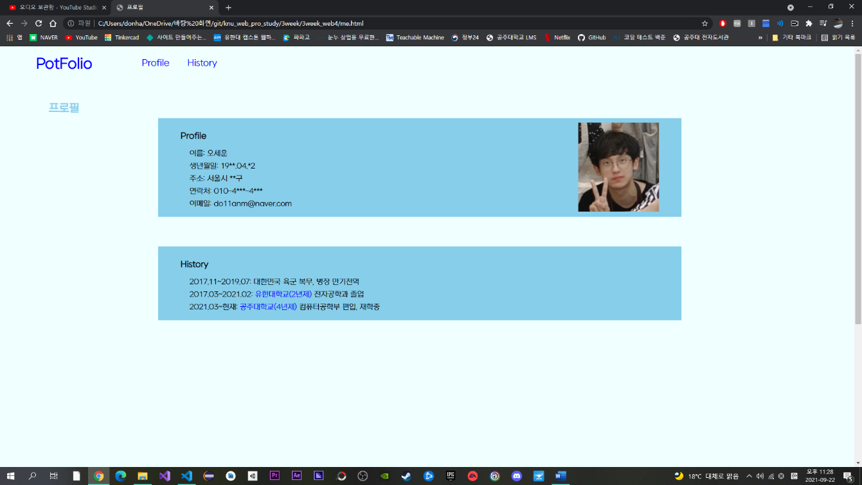

프로필을 새로 만들고 사진도 넣어줬습니다.

취미 화면

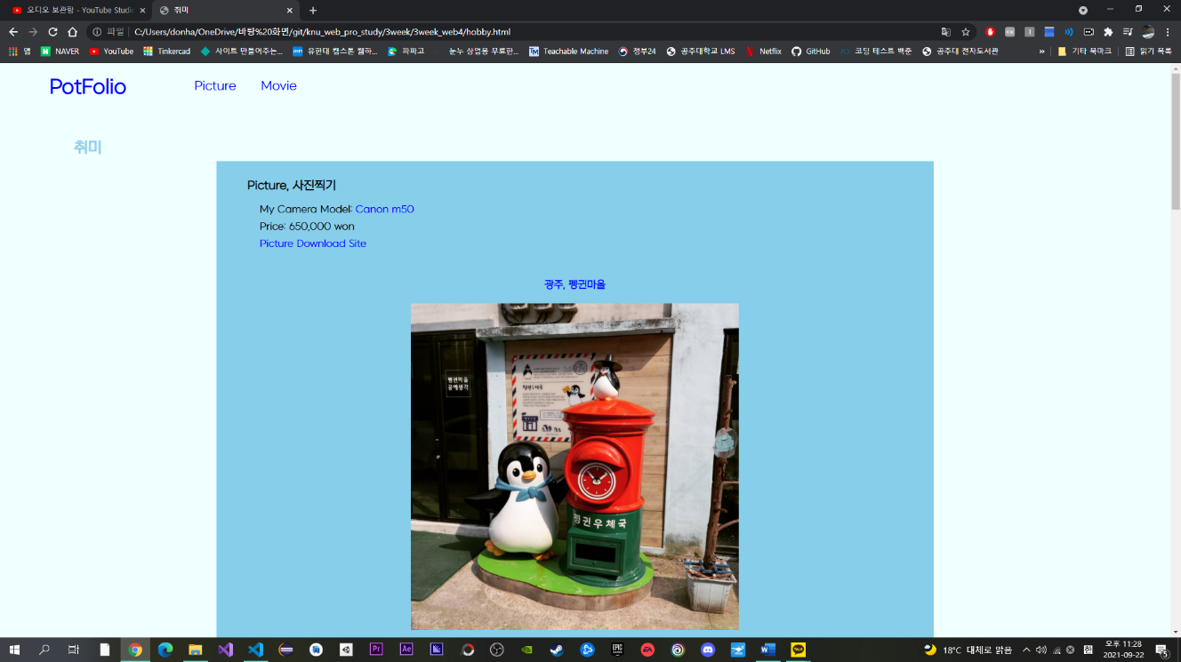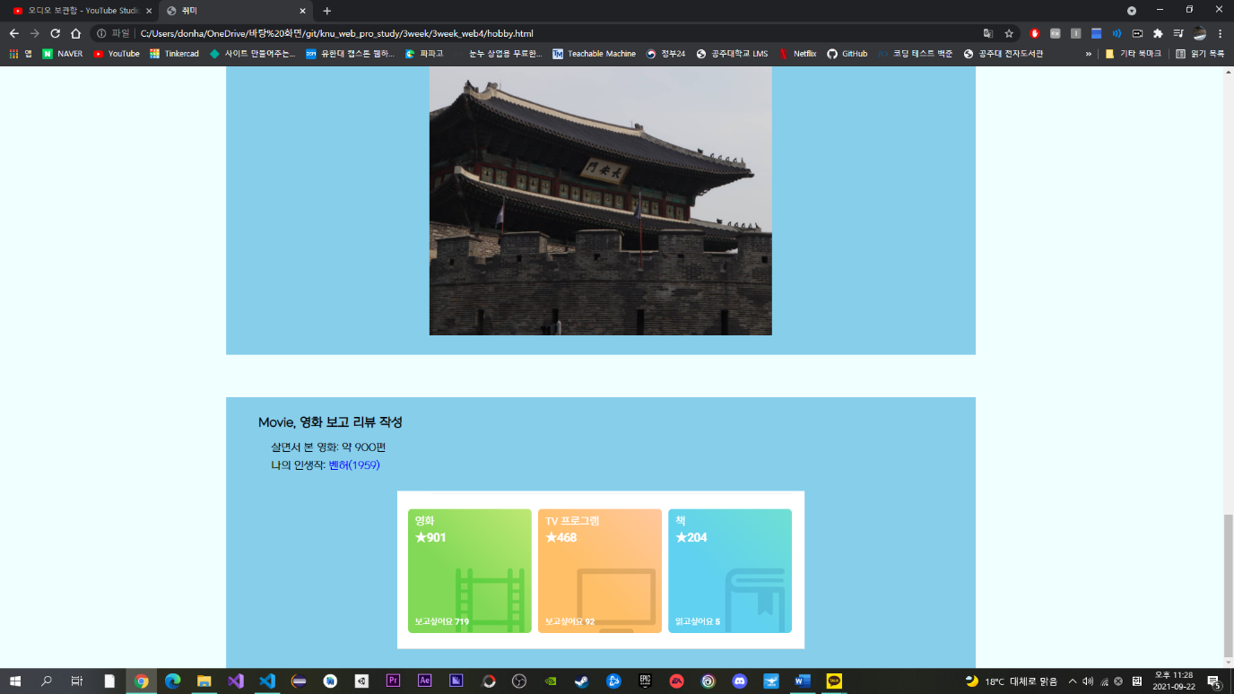

로그인 화면

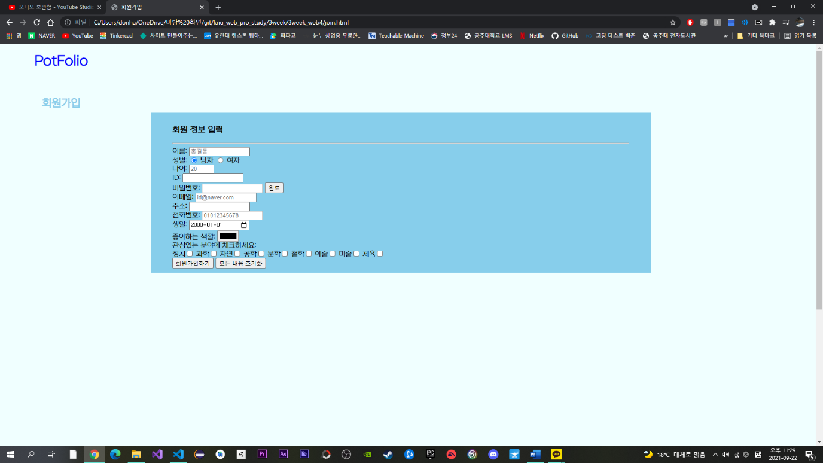

로그인 화면 양식을 따로 만들어 보았습니다.

**Index.html**

<!DOCTYPE *html*>

<html *lang*="en">

<head>

    <meta *charset*="UTF-8">

    <meta *http-equiv*="X-UA-Compatible" *content*="IE=edge">

    <meta *name*="viewport" *content*="width=device-width, initial-scale=1.0">

    <link *rel*="stylesheet" *href*="pf.css">

    <title>포트폴리오</title>

</head>

<body>

    <div *class*="bg">

        <header>

            <h1 *id*="name">PotFolio</h1>

        </header>

        <aside></aside>

        <nav>

            <ul>

                <li><a *href*="self_intro.html" *title*="자소서 보기">자기소개서</a></li>

                <li><a *href*="me.html" *title*="프로필 보기">프로필</a></li>

                <li><a *href*="hobby.html" *title*="취미 보기">취미</a></li>

                <li><a *href*="join.html" *title*="회원가입 하러가기">회원가입</a></li>

            </ul>

        </nav>

        <footer>

            <figure>

                <figcaption>Music Player</figcaption>

                <audio *src*="music/No.4 Piano Journey - Esther Abrami.mp3" *controls*></audio>

            </figure>

        </footer>

    </div>

</body>

</html>

**self_intro.html**

<!DOCTYPE *html*>

<html *lang*="en">

<head>

    <meta *charset*="UTF-8">

    <meta *http-equiv*="X-UA-Compatible" *content*="IE=edge">

    <meta *name*="viewport" *content*="width=device-width, initial-scale=1.0">

    <link *rel*="stylesheet" *href*="si.css">

    <title>자소서</title>

</head>

<body>

    <header>

        <h1><a *href*="index.html" *title*="메인으로 돌아가기">PotFolio</a></h1>

    </header>

    <nav>

        <ul *id*="navUl">

            <li><a *href*="#chap1" *title*="성장과정 보러가기">성장과정</a></li>

            <li><a *href*="#chap2" *title*="자신의 강점 보러가기">타인이 말하는 자신의 강점</a></li>

            <li><a *href*="#chap3" *title*="취미 보러가기">취미</a></li>

            <li><a *href*="#chap4" *title*="성격 보러가기">성격</a></li>

        </ul>

    </nav>

    <aside>

        <h2>자기소개서</h2>

    </aside>

    <section>

        <article *id*="chap1">

            <h3><a *href*="https://www.jobkorea.co.kr/goodjob/tip/view?News_No=18428&schCtgr=0&Page=1"

*title*="자소서 성장 과정 작성법 바로가기" *target*="_blank">성장 과정</a></h3>

            <p><span>저는 초등학생 시절부터 많은 경험을 해왔습니다.</span> 부모님은 저에게 공부에 재능이 없다는 것을 느끼시고 공부 말고 밖을 나가서 새로운 사람, 새로운 세상을 경험하라고

                종종 하셨습니다.

                이것이 제가 남들과는 다르게 많은 것을 경험할 수 있었던 이유였습니다. 그 덕에 어릴 때 바이올린, 합기도, 피아노 등을 배우면서 운동을 통해 건강을 악기 연주를 통해 심신의

                안정을 터득할 수 있게 되었습니다.</p>

            <p>그러나 뭐든지 조금 잘할 뿐 뛰어나게 잘하는 것은 없었습니다. 이것이 문제였습니다. 하고 싶은 것이 있으면 부모님은 무엇이든 할 수 있게 해 주셨지만, 흥미가 금방 수그러들어 오래

                배우지 못했습니다. </p>

            <p>어렸을 때부터 공부는 못 했지만, 공학에 관심이 많았습니다. 고장 난 가전제품이나 핸드폰 등을 분해해서 관찰하고 망가진 게 있으면 고치고 했습니다. 공과 대학을 진학하면서 공부라면

                치를 떨던 저는 학교 수업이 끝나면 바로 집에 가지 않고 도서관에서 친구들에게 제가 가진 공학 지식을 알려주며 같이 공부를 했습니다. 그렇게 공부를 하면서 열정을 가지고 임할 때

                그 효과가 대단하다는 것을 그때 느꼈습니다.</p>

            <p>지금 생각해보면 누군가에게는 쓸데없는 짓으로 보이던 행동이 저의 공학 지식을 넓히고, 제 사고를 확장할 수 있었다고 생각합니다. 그리고 다양한 경험을 통해 제가 좋아하는 것을 찾을

                수 있게 도와주신 부모님이 계셨기에 제가 열정을 느낄 수 있었다고 생각합니다. 현재는 열정을 통해 느꼈던 전율을 잊지 않고 모든 일에 열정을 쏟는 자세로 임하고 있습니다.</p>

        </article>

        <article *id*="chap2">

            <h3>타인이 말하는 자신의 강점</h3>

            <p><span>저는 사람과 대화할 때 말을 하는 것보다 상대방이 하는 말을 듣는 것을 좋아합니다.</span> 저는 어렸을 때 말주변이 없어서 말을 많이 하지 않습니다. 그러다 보니 친구들이랑

                대화할 때 제가

                말하면 재미없다고 놀림을 받을 때가 더 많았습니다. 그래서 저 자신이 많이 미운 적도 있었습니다.</p>

            <p>하지만 중학생 시절 이런 생각이 들었습니다. ‘많은 사람이 자기를 표현할 줄만 알지 상대방을 알려고 하지 않는다’라는 생각이 들었고 그때부터 말을 하면서 대화를 이끄는 게 아닌

                경청을 통해 상대방의 말을 들으면서 공감하고 반응하며 대화를 이끌어 나가게 되었습니다.</p>

            <p>이러한 상대방의 말에 공감하고 반응하는 경청하는 훈련을 통해 군대에서는 후임이나 선임들 그리고 동기들이 고민 상담을 원하면 들어주고 고민이나 하고 싶은 말을 캐치하고 도와주면서

                상대방이 회복되는 것을 보며 뿌듯했습니다. 이러한 경험을 통해 자신의 단점, 잘하지 못하는 것을 열심히 노력해서 고치는 것도 중요하지만 단점을 통해 새로운 장점을 발견하게 되고

                그것을 자신의 것으로 개발하는 것도 중요하다는 것을 알게 되었습니다.</p>

        </article>

        <article *id*="chap3">

            <h3><a *href*="https://www.jobkorea.co.kr/goodjob/tip/view?News_No=18854&schCtgr=0&Page=1"

*title*="자소서 취미, 특기 작성법 바로가기" *target*="_blank">취미</a></h3>

            <p><span>취미는 영화입니다.</span> 근데 영화를 보기만 하는 것이 아닌 SNS에 영화를 보고 느낀 점과 저만의 해석을 쓴 글을 올립니다. 그러다 영화라는 것이 사람들과 소통하기에

                안성맞춤이라는 생각이 들었습니다.</p>

            <p>하나의 영화를 볼 때 다른 사람들에게 영화가 어땠냐고 물어보면 다양한 시각, 해석, 느낀 점이 나옵니다. 저는 다른 사람들이 쓴 논평을 읽고 서로 느낀 점을 주고받고 이야기하며 서로

                다른 생각을 공유하는 것이 영화의 매력이라고 생각합니다.</p>

            <p>저는 컴퓨터공학부에 전과 편입하게 되면서 프로그래밍이라는 학문을 다르게 보게 되었습니다. 아직 많이 접하지 못해 익숙하지 않아서 어렵긴 하지만 어떤 결과를 도출하는 프로그램을

                만들라고 할 때 다른 사람들이 쓴 것을 비교해보면 영화 논평처럼 내용, 언어, 길이 등 많은 것이 다르기 때문입니다. 그렇게 제가 작성한 코드와 다른 사람들이 작성한 코드를 보면서

                뭐가 더 효율적이고 좋은 코드인지 알아가는 재미가 들리면서 흥미가 생겼습니다.</p>

        </article>

        <article *id*="chap4">

            <h3><a *href*="https://www.jobkorea.co.kr/goodjob/tip/view?News_No=18854&schCtgr=0&Page=1"

*title*="자소서 성격 작성법 바로가기" *target*="_blank">성격</a></h3>

            <p><span>저는 궁금한 것을 참지 못하는 성격입니다.</span> 이러한 점은 ‘배우는 일’에 있어 많이 드러납니다. 무언가 궁금한 점이 생기면 저는 그 즉시 궁금증을 해결하기 위해 책이나

                인터넷을 동원합니다. 그 궁금증을 해소하기 위한 노력의 과정에서 또 다른 궁금증이 생기게 되곤 하는데 이렇게 점층적으로 궁금증을 해결해 나가면서 성장해 나갈 수 있었다고 생각합니다.

            </p>

            <p>대인관계에 있어 저는 적극적으로 다가가는 성격은 아니었습니다. 그러나 군인 시절 낯을 많이 가리던 저는 우리나라의 각 지역에서 사는 동기, 선, 후임을 만나면서 사람을 만나고

                대화하는 것을 좋아하는 성격으로 변화하게 되었습니다. </p>

            <p>처음에는 저도 놀라웠습니다. 처음 보는 사람에게 먼저 다가가고 친근하게 말 붙이는 저를 상상해 본 적이 없었기 때문입니다. 이러한 점에 있어서 군 생활이 힘들었지만, 저에게 많은

                것을 주었다고 생각합니다. 저는 일단 친해지면 그 관계가 오래 지속되는 성격입니다. 친해지기까지가 조금 시간이 걸린다는 것이 단점이라면 단점이었는데 지금은 스스럼없이 쉽게 다가가는

                성격의 변화를 겪게 되었습니다.</p>

        </article>

    </section>

    <aside></aside>

    <footer></footer>

</body>

</html>

**me.html**

<!DOCTYPE *html*>

<html *lang*="en">

<head>

    <meta *charset*="UTF-8">

    <meta *http-equiv*="X-UA-Compatible" *content*="IE=edge">

    <meta *name*="viewport" *content*="width=device-width, initial-scale=1.0">

    <link *rel*="stylesheet" *href*="si.css">

    <title>프로필</title>

</head>

<body>

    <header>

        <h1><a *href*="index.html" *title*="메인으로 돌아가기">PotFolio</a></h1>

    </header>

    <nav>

        <ul *id*="navUl">

            <li><a *href*="#profile" *title*="Profile 보러가기">Profile</a></li>

            <li><a *href*="#History" *title*="History 보러가기">History</a></li>

        </ul>

    </nav>

    <aside>

        <h2>프로필</h2>

    </aside>

    <section>

        <article *id*="profile">

            <img *id*="profileImg" *src*="picture/프로필 사진.jpg" *width*="10%" *alt*="">

            <h3>Profile</h3>

            <p>이름: 오세훈</p>

            <p>생년월일: 19**.04.*2</p>

            <p>주소: 서울시 **구</p>

            <p>연락처: 010-4***-4***</p>

            <p>이메일: do11anm@naver.com</p>

        </article>

        <article *id*="History">

            <h3>History</h3>

            <p>2017.11~2019.07: 대한민국 육군 복무, 병장 만기전역</p>

            <p>2017.03~2021.02: <a *href*="https://www.yuhan.ac.kr/index.do" *title*="대학 홈페이지 바로가기">유한대학교(2년제)</a> 전자공학과 졸업</p>

            <p>2021.03~현재: <a *href*="https://www.kongju.ac.kr/main_1.jsp" *title*="대학 홈페이지 바로가기">공주대학교(4년제)</a> 컴퓨터공학부 편입, 재학중</p>

        </article>

    </section>

    <aside></aside>

    <footer></footer>

</body>

</html>

**hobby.html**

<!DOCTYPE *html*>

<html *lang*="en">

<head>

    <meta *charset*="UTF-8">

    <meta *http-equiv*="X-UA-Compatible" *content*="IE=edge">

    <meta *name*="viewport" *content*="width=device-width, initial-scale=1.0">

    <link *rel*="stylesheet" *href*="si.css">

    <title>취미</title>

</head>

<body>

    <header>

        <h1><a *href*="index.html" *title*="메인으로 돌아가기">PotFolio</a></h1>

    </header>

    <nav>

        <ul *id*="navUl">

            <li><a *href*="#myPicture" *title*="Picture 바로보기">Picture</a></li>

            <li><a *href*="#myMovie" *title*="Movie 바로보기">Movie</a></li>

        </ul>

    </nav>

    <aside>

        <h2 *id*="name">취미</h2>

    </aside>

    <section>

        <article *id*="myPicture">

            <h3>Picture, 사진찍기</h3>

            <p>My Camera Model: <a *href*="https://search.shopping.naver.com/catalog/13852022048?query=%EC%BA%90%EB%85%BC%20m50&NaPm=ct%3Dktvkojx4%7Cci%3D0cda65494868a1267111aeb9bac7eb6e26c73cb3%7Ctr%3Dslsl%7Csn%3D95694%7Chk%3Dde4cfcb93369f839467020fabc992252d953ed3a"

*title*="네이버 쇼핑 바로가기" *target*="_blank">Canon m50</a></p>

            <p>Price: 650,000 won</p>

            <p><a *href*="https://unsplash.com/photos/zP40uSA5Y5w" *title*="내가 찍은 사진 다운로드 하러가기" *target*="_black" *alt*="언스플래쉬">Picture Download Site</a></p>

            <br>

            <h4><a *href*="https://ko.wikipedia.org/wiki/%EA%B4%91%EC%A3%BC%EA%B4%91%EC%97%AD%EC%8B%9C" *title*="광주, 위키백과" *target*="_blank">광주, 펭귄마을</a></h4>

            <img *id*="hobbyImg" *src*="picture/광주2.jpg" *alt*="광주">

            <h4><a *href*="https://ko.wikipedia.org/wiki/%EB%AA%A9%ED%8F%AC%EC%8B%9C" *title*="목포, 위키백과" *target*="_blank">목포, 고하도</a></h4>

            <img *id*="hobbyImg" *src*="picture/목포.jpg" *alt*="목포">

            <h4><a *href*="https://ko.wikipedia.org/wiki/%EC%97%AC%EC%88%98%EC%8B%9C" *title*="여수, 위키백과" *target*="_blank">여수, 엑스포</a></h4>

            <img *id*="hobbyImg" *src*="picture/여수.webp" *alt*="여수">

            <h4><a *href*="https://ko.wikipedia.org/wiki/%EC%A0%84%EC%A3%BC%EC%8B%9C" *title*="전주, 위키백과" *target*="_blank">전주, 한옥마을</a></h4>

            <img *id*="hobbyImg" *src*="picture/전주.jpg" *alt*="전주">

            <h4><a *href*="https://ko.wikipedia.org/wiki/%EC%88%98%EC%9B%90%EC%8B%9C" *title*="수원, 위키백과" *target*="_blank">수원, 화성</a></h4>

            <img *id*="hobbyImg" *src*="picture/수원.jpg" *alt*="수원">

        </article>

        <article *id*="myMovie">

            <h3>Movie, 영화 보고 리뷰 작성</h3>

            <p>살면서 본 영화: 약 900편</p>

            <p>나의 인생작: <a *href*="https://ko.wikipedia.org/wiki/%EB%B2%A4%ED%97%88_(1959%EB%85%84_%EC%98%81%ED%99%94)" *title*="벤허, 위키백과" *target*="_blank">벤허(1959)</a></p>

            <a *href*="https://pedia.watcha.com/ko-KR" *title*="왓챠피디아 바로가기"><img *src*="picture/왓챠피디아.PNG" *alt*="왓챠피디아"></a>

        </article>

    </section>

    <aside></aside>

    <footer></footer>

</body>

</html>

**join.html**

<!DOCTYPE *html*>

<html *lang*="en">

<head>

    <meta *charset*="UTF-8">

    <meta *http-equiv*="X-UA-Compatible" *content*="IE=edge">

    <meta *name*="viewport" *content*="width=device-width, initial-scale=1.0">

    <link *rel*="stylesheet" *href*="si.css">

    <title>회원가입</title>

</head>

<body>

    <header>

        <h1><a *href*="index.html" *title*="메인으로 돌아가기">PotFolio</a></h1>

    </header>

    <nav>

    </nav>

    <aside>

        <h2>회원가입</h2>

    </aside>

    <section>

        <article>

            <h3>회원 정보 입력</h3>

            <hr>

            <form *action*="">

                <label *for*="">이름: <input *type*="text" *size*="15" *placeholder*="홍길동"></label><br>

                <label *for*="">

                    성별:

                    <input *type*="radio" *name*="sex" *value*="1" *checked*>

                    남자

                    <input *type*="radio" *name*="sex" *value*="2">

                    여자</label><br>

                <label *for*="">나이: <input *type*="text" *size*="3" *placeholder*="20"></label><br>

                <label *for*="">ID: <input *type*="text" *size*="15"></label><br>

                <label *for*="pass">비밀번호: </label>

                <input *id*="pass" *type*="password" *size*="15">

                <input *type*="submit" *value*="완료"><br>

                <label *for*="">이메일: <input *type*="email" *size*="15" *placeholder*="id@naver.com"></label><br>

                <label *for*="">주소: <input *type*="text" *list*="address" *size*="15">

                <datalist *id*="address">

                    <option *value*="서울특별시"></option>

                    <option *value*="부산광역시"></option>

                    <option *value*="대구광역시"></option>

                    <option *value*="인천광역시"></option>

                    <option *value*="광주광역시"></option>

                    <option *value*="대전광역시"></option>

                    <option *value*="울산광역시"></option>

                    <option *value*="경기도"></option>

                    <option *value*="강원도"></option>

                    <option *value*="충청북도"></option>

                    <option *value*="충청남도"></option>

                    <option *value*="전라북도"></option>

                    <option *value*="전라남도"></option>

                    <option *value*="경상북도"></option>

                    <option *value*="경상남도"></option>

                    <option *value*="제주특별자치도"></option>

                    <option *value*="세종특별자치시"></option>

                </datalist></label><br>

                <label *for*="">전화번호: <input *type*="text" *size*="15" *placeholder*="01012345678"></label><br>

                <label *for*="">생일: <input *type*="date" *value*="2000-01-01"></label><br>

                <label *for*="">좋아하는 색깔: <input *type*="color"></label><br>

                <label *for*="">관심있는 분야에 체크하세요: <br>

                    정치<input *type*="checkbox" *value*="1">

                    과학<input *type*="checkbox" *value*="2">

                    자연<input *type*="checkbox" *value*="3">

                    공학<input *type*="checkbox" *value*="4">

                    문학<input *type*="checkbox" *value*="5">

                    철학<input *type*="checkbox" *value*="6">

                    예술<input *type*="checkbox" *value*="7">

                    미술<input *type*="checkbox" *value*="8">

                    체육<input *type*="checkbox" *value*="9">

                </label><br>

                <label *for*=""> <input *type*="submit" *value*="회원가입하기"></label>

                <label *for*=""> <input *type*="reset" *value*="모든 내용 초기화"></label><br>

            </form>

        </article>

    </section>

    <aside></aside>

    <footer></footer>

</body>

</html>

**pf.Css**

*@font-face* { */*외부 폰트 지정*/*

    font-family: 'NEXON Lv1 Gothic OTF';

    src: url('https://cdn.jsdelivr.net/gh/projectnoonnu/noonfonts_20-04@2.1/NEXON Lv1 Gothic OTF.woff') format('woff');

    font-weight: normal;

    font-style: normal;

}

*.bg*{ */*메인화면 사진 적용*/*

    background-image: url(picture/pic1.jpg);

    height: 100%;

    background-position: center;

    background-repeat: no-repeat;

    background-size: cover;

}

html, body {

    margin: 0;

    padding: 0;

    height: 100%;

    font-family: "NEXON Lv1 Gothic OTF"; */*웹사이트에 폰트 적용*/*

}

header {

    width: 15%;

    height: 10%;

    float: left;

    text-align: center;

    background-color:azure;

}

section {

    width: 85%;

    height: 100%;

    float: left;

}

aside{

    width: 85%;

    height: 10%;

}

nav {

    width: 15%;

    height: 80%;

*/* float: center; */*

    background-color:azure;

}

footer{

    width: 15%;

    height: 10%;

    clear: both; */*footer를 아래에 고정*/*

    background-color:azure;

}

h1{

    color: skyblue;

}

a{

    color: blue;

    text-decoration: none;

}

ul{

    list-style: none; */*li의 점 제거*/*

    margin: 0;

    padding: 0;

}

li{

    padding-top: 20px;

    padding-bottom: 20px;

    text-align: center;

    font-size: 20px;

}

figure{

    margin: 0;

}

**si.Css**

*@font-face* {

    font-family: 'NEXON Lv1 Gothic OTF';

    src: url('https://cdn.jsdelivr.net/gh/projectnoonnu/noonfonts_20-04@2.1/NEXON Lv1 Gothic OTF.woff') format('woff');

    font-weight: normal;

    font-style: normal;

}

*#write* {

    padding: 30px;

    margin: 0;

}

*#navUl* {

    padding: 10px;

}

*#hobbyImg*{

    width: 50%;

}

*#profileImg*{

    margin: 0;

    float: right;

    width: 180px;

}

html,body {

    margin: 0;

    padding: 0;

    height: 100%;

    width: 100%;

    background-color: azure;

    font-family: "NEXON Lv1 Gothic OTF";

}

header {

    width: 15%;

    height: 10%;

    float: left;

    text-align: center;

}

nav {

    width: 85%;

    height: 10%;

    float: left;

}

article {

    padding-left: 50px;

    padding-right: 50px;

    padding-top: 10px;

    padding-bottom: 10px;

    margin: 5%;

    text-align: left;

    width: 80%;

    background-color: skyblue;

}

p {

    margin: 0;

    padding-bottom: 10px;

    text-indent: 20px;

}

section {

    width: 70%;

    height: 100%;

    float: left;

}

aside {

    width: 15%;

    height: 130%;

    float: left;

}

footer {

    width: 100%;

    height: 10%;

    clear: both;

}

h2 {

    padding: 10px;

    text-align: center;

    color: skyblue;

}

a {

    color: blue;

    text-decoration: none;

}

li {

    list-style-type: none;

    float: left;

    font-size: 20px;

    margin-left: 20px;

    margin-right: 20px;

}

span {

    color: darkblue;

    font-size: 20px;

}

img{

    display: block;

    margin-top: 20px;

    margin-bottom: 20px;

    margin-left: auto;

    margin-right: auto;

}

h4{

    text-align: center;

}